**Smart Mi Introduction**

## **Background**

Glasses frame selection tends to be a challenging phase in the selling process for optometrists. It might demand significant attention by the optometrist, who is required to advise the patient regarding both optometric and visual match of a wide variety of frames to the patient’s face.

Smart Mi instrument is designed to assist the optometrist handling the frame selection challenge. It enables the patient to compare his look while wearing multiple frames simultaneously, with detailed score for the fit of the frames to his face attached.

The patient may select multiple frames of his taste and capture himself with each one of them. Smart Mi displays the patient’s images simultaneously and grades the fit of each frame to the patient’s face.

**Comparison of 3 frames fit. Total matching score for each fit is represented on the images upper left corner.**

## **Matching score**

The matching score consists of variety of frame-face features. These features are weighted to obtain a total matching score.

We use python ‘MediaPipe’ package to detect frame features. The package enables detection of 478 face landmarks in real-time speed. We use these landmarks to extract the relevant face features. Additionally, deep learning model shall be applied to detect the glasses frame.

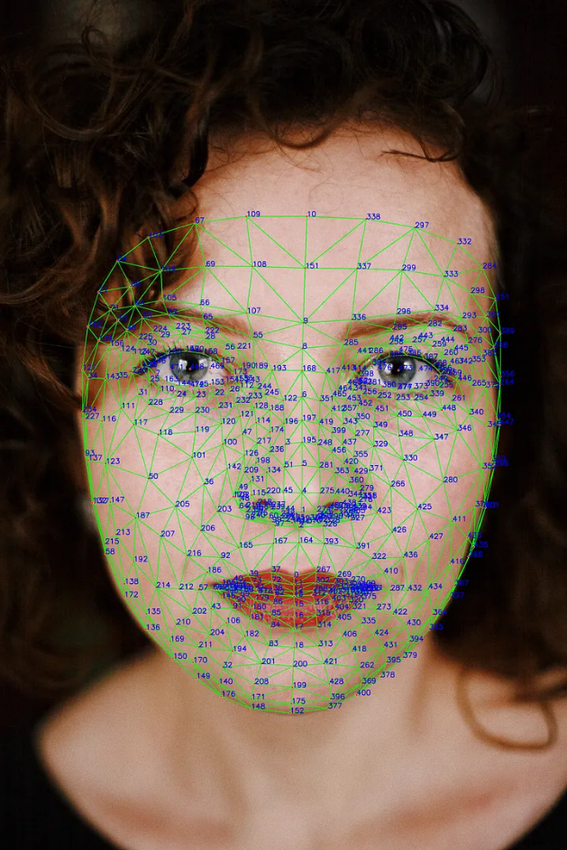

**Landmarks detected by python MediaPipe package.**

List of frame-face features, as considered currently:

1. Frame width comparing to patient’s face.
2. Correlation between frame’s upper side and the patient’s eyebrows.
3. The distance between frame’s lower side to the patient’s lower cheek line.
4. Asthetics of the frame shape w.r.t. the patient’s face.
5. Frame DBL w.r.t. patient’s nose width.
6. Frame color w.r.t. patient’s skin color.

Frame-face features might be changed, added, eliminated, or weighted differently, as research may demonstrate later.

1. **Frame width**

Frame orientation is determined by a symmetry line between the lenses. Then, frame width is calculated by the two points on the frame obtaining maximum horizontal difference w.r.t. the symmetry line.

Face width is calculated by the distance of the two landmarks at the pupils’ height.

We grade similar frame and face widths with perfect score and reduce the grade as the difference increases.

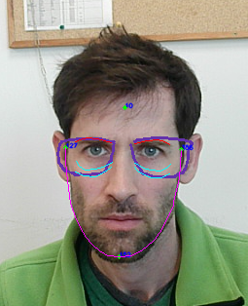

**Frame width**

**Face width**

**Frame symmetry line**

1. **Correlation between frame and eyebrows**

We calculate the frame points closest to the eyebrow points, and grade based on the distance and shape difference between the frame and eyebrow. Small distance and shape difference are graded higher.

The feature is graded as the average of the left and right frame-eyebrows correlation grades.



**Right eyebrow**

**Left eyebrow**

**Frame sections which should correlate to the eyebrows**

1. **Frame’s lower side w.r.t. lower cheek line**

The frame fits better to the patient if the lenses don’t lay on the patient’s cheeks. Thus, we verify that the lenses’ lower parts are located above the cheeks lower line. Here the grade is binary for each lens – 10 if the lens is above the lower cheek line and 0 otherwise.

Again, the feature is graded as the average of the two lenses grades.



**Right lower cheek line**

**Left lower cheek line**

**Frame’s lower side w.r.t. lower cheek line. Here both lenses intersect the cheek lines, hence both sides are graded 0.**

1. **Frame shape w.r.t. face**

Rounded shape lenses are considered as a better fit for rectangular face, and vice versa - rectangular shape lenses are considered as a better fit for rounded face. For oval faces, any shape lenses are considered as a good fit.

Thus, the frame shape score is based on two features – circularity of the lenses and the face, and the face aspect ratio.

Circularity is calculated by best fit circle score normalized to $\left[0,1\right]$. Higher circularity score means that the feature (lens or face) is more circular. Aspect ratio is the ratio between the patient’s face height and width. Higher aspect ratio means that the face is more oval (and less circular).

As stated, higher score is granted for oval faces, or for frames with opposite circularity than the face (if the face is not oval).

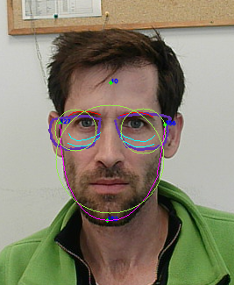

**Best fit circles**

**Jaw line**

**Face height**

**Face width**

1. **DBL w.r.t. nose width**

Both DBL and nose width are calculated by the distance of the two points. DBL by two bridge points and nose width by two landmarks at the pupils’ height.

We grade perfect score if the nose width is greater or equal to DBL and reduce the grade as the ratio $\frac{DBL}{Nose width}$ increases. Above a certain threshold, the grade is 0.



**DBL**

**Face nose width**

1. **Frame color w.r.t. skin color**

Skin color is calculated as the average of RGB values of pixels at multiple landmark locations, including cheeks, nose and forehead.

Frames of different color than the skin are considered a better fit. Thus, we grade perfect score if the (Euclidean distance) difference between the frame and skin RGB values exceeds a certain threshold and reduce the grade as the Euclidean distance decreases.



**Frame color**

**Skin color**

## **Examples**

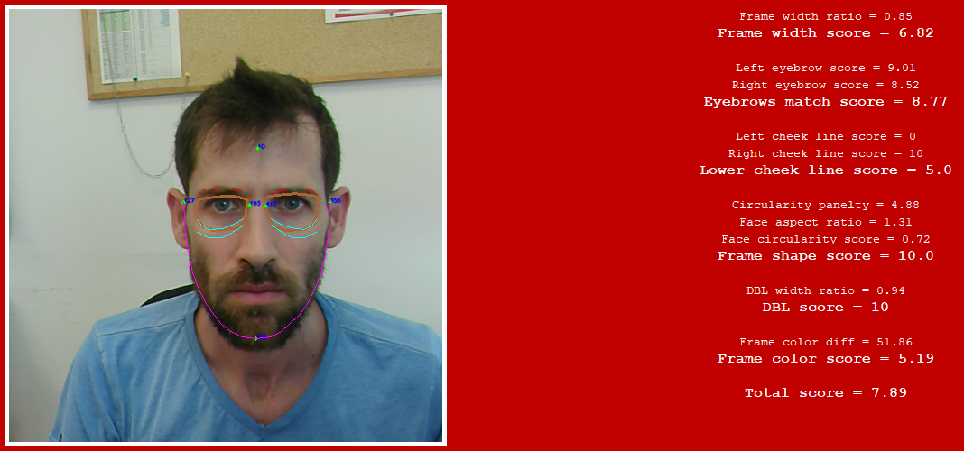

**Detailed score examples. In the upper image, the frame fits better to the face.**